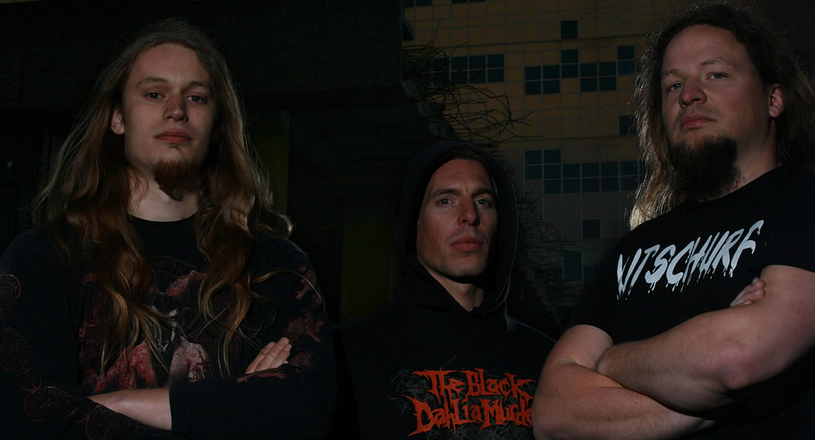

PRESS RELEASE

April 29, 2017 - for immediate release:

Bloodgod Releasing New EP ‘Catharsis’
Second studio release from Dutch metal band available on CD on April 30, 2017

Dutch metal moloch Bloodgod, featuring (former) members of Disquiet, Hymir and Nuestros Derechos, drops a new EP called ‘Catharsis’. The band’s second studio recording, also available through various digital music platforms, will be released on CD on April 30, 2017.

Five brand new tracks were recorded and mixed at Mass Audio Studio in the Netherlands, and mastered by Grammy nominated engineer Jacob Hansen (Aborted, Mercenary, Volbeat, Pestilence, etc) in Denmark.

The artwork depicts ‘t Schrickelik Tempeest, meaning 'the horrible tempest' in old Dutch. It refers to the song with the same title and lyrics about the violent storm of August 1, 1674 that hit the episcopal cathedral in the band’s hometown Utrecht and turned it into ruins.

Watch the official lyric video of the EP’s opening track, Valar Morghulis, on YouTube: http://bit.ly/pr3v13w.

Following the release of their debut EP ‘Pseudologia Phantastica’ (2013), Bloodgod shared the stage with Can of Worms, Cryptopsy, Skeletal Remains, and Terrorizer among others, and played several festivals including Big Ass Metal Fest, Angelfest Doetinchem and Frisian Brotherhood Fest.

* * * * * * * * * * * * * * * * * * * * * * * * * * END OF PRESS RELEASE * * * * * * * * * * * * * * * * * * * * * * * * * *
Editorial notes (not for publication):  If you would like more information, photos or schedule an interview, please mail to info@bloodgod.nl or call +31 6 225 46 554.  Electronic press kit (EPK): http://www.bloodgod.nl/epk.html.  Links:  - http://www.bloodgod.nl - official website  - https://www.facebook.com/bloodgod.metal - facebook  - http://www.youtube.com/bloodgodmetal - youtube  - https://www.instagram.com/bloodgodmetal/ - instagram  - https://bloodgod.bandcamp.com/ - bandcamp  - https://twitter.com/bloodgod_metal - twitter | 